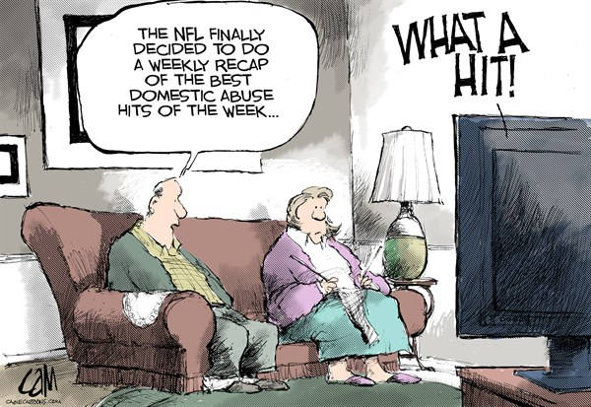

This picture is saying the NFL decided to do weekly recaps of domestic abuse. This is supposed to poke fun at Ray Rice. He hit his now wife, Nancy Giles. Was hit by Ray rice because of an argument the two of them where having, and it happen to be catch all on camera.

The political cartoon is hard to tell what side of the fence the cartoonist is on. The cartoon is probably a liberate. Republic is are lose with beatings, and are just hillbillies. How just like beer, gun and that ‘merica is just a free nation to do what they please. Even inbreeding and beating their wife’s when their drunk.

I agree that it’s wrong it hit a women, in most cases, but how this was happen was pretty had. He should be fired but we the general population do not need to know about their personal life. In the end this will never go away for the ether of them. We don’t really know it got so heat, so we are in no right to make a judgment on them.